

SIMATS ENGINEERING
Saveetha Institute of Medical and Technical Sciences
Chennai–602105
A CAPSTONE PROJECT REPORT
EARLY FOREST FIRE PREDICTION AND ALERT SYSTEM WITH HEAT MAP-BASED WILDLIFE AND VEGETATION PROTECTION
A Capstone Project Report submitted in partial fulfilment of the requirements
for the Course of
CSA1109 – Object Oriented Analysis and Design
to the award of the degree of
BACHELOR OF TECHNOLOGY
IN COMPUTER SCIENCE AND ENGINEERING
Submitted by
Chethrika Sri (192511112)
Under the Supervision of
Dr. Mary Valentina
SEPTEMBER 2026

Saveetha Institute of Medical and Technical Sciences
Chennai–602105
BONAFIDE CERTIFICATE
This is to certify that the Capstone Project entitled “Early Forest Fire Prediction and Alert System with Heat Map-Based Wildlife and Vegetation Protection” has been carried out by Chethrika Sri (Reg. No. 192511112) under the supervision of Dr. Mary Valentina and is submitted in partial fulfilment of the requirements for the current semester at Saveetha Institute of Medical and Technical Sciences, Chennai.

COURSE COORDINATOR | COURSE FACULTY
Dr.M.Ramamoorthy | Dr.G.Mary Valantina
Professor | Professor
Department:CSE  SIMATS ENGINEERING | Department:ECE  SIMATS ENGINEERING

SIMATS ENGINEERING
Saveetha Institute of Medical and Technical Sciences
Chennai–602105
DECLARATION
We, Chethrika Sri (192511112) , hereby declare that the Capstone Project Work entitled “Early Forest Fire Prediction and Alert System with Heat Map-Based Wildlife and Vegetation Protection” is the result of our own bonafide efforts. To the best of our knowledge, the work presented herein is original, accurate, and has been carried out in accordance with the principles of engineering ethics and academic integrity. All sources, references, data, and other materials used in the project have been appropriately acknowledged. We further declare that the data, results, analysis, and findings presented in this report have not been fabricated, falsified, or manipulated. Any external tools, software, datasets, computational resources, or AI-assisted tools used during the project have been appropriately disclosed. We confirm that applicable ethical, academic, institutional, and professional requirements have been followed throughout the planning, execution, analysis, and documentation of the project.
Place: Chennai
Date: 08/09/26
Signature of the Students with Names
Chethrika Sri (192511112)

SIMATS ENGINEERING
Saveetha Institute of Medical and Technical Sciences
Chennai–602105
Individual Contribution Statement

Student Name / Register No. | Specific Responsibilities | Design & Development Contribution | Testing & Analysis Contribution | Report Contribution | Approx. Contribution (%)
Chethrika Sri / 192511112 | Module 1 – User Authentication & Forest Monitoring; Module 3 – Priority-Based Heat Map Generation; system integration support. | Design of secure access/monitoring workflow and heat-map priority logic. | Review of environmental-data flow, risk classification and priority assignment requirements. | Chapters 1, 3, 5 and assigned module sections. | 60%
Kamali R / 192521217 | Module 2 – Forest Fire Prediction; prediction workflow and related documentation. | Design of threshold/historical-pattern prediction workflow. | Review of risk classification and prediction validation requirements. | Chapter 2 and assigned prediction sections. | 40%
Total |  |  |  |  | 100%

ABSTRACT

Forest fires are a major environmental challenge because they can spread rapidly and cause irreversible damage to vegetation, wildlife, biodiversity, ecosystems, nearby communities, and property. The project addresses the limitations of conventional fire detection approaches that depend heavily on manual surveillance and may detect fires only after ignition, leading to delayed response. The proposed Early Forest Fire Prediction and Alert System with Heat Map-Based Wildlife and Vegetation Protection uses real-time environmental information including temperature, smoke level, humidity, weather conditions, and GPS location to identify abnormal conditions and predict potential fire risk at an early stage. The system is organized into four modules: User Authentication & Forest Monitoring, Forest Fire Prediction, Priority-Based Heat Map Generation, and Alert & Emergency Notification. The prediction module compares sensor values with predefined thresholds and considers historical forest-fire patterns and current environmental conditions to classify risk as Low, Medium, High, or Critical. The heat-map module combines fire-risk information with wildlife density and vegetation coverage to prioritize ecological zones for response. High and Critical risk conditions trigger notifications to authorized forest officials containing location and risk information. The design emphasizes secure access, real-time monitoring, risk prioritization, traceability, and rapid emergency communication. The project supports Sustainable Development Goal 15 – Life on Land by focusing on protection of forests, wildlife, and vegetation. The supplied presentation does not provide quantitative deployment or test measurements, so this report distinguishes planned verification from measured results and does not invent numerical performance values. Future development proposed by the project includes satellite and drone integration, advanced AI models for fire-spread prediction, a mobile application, automatic emergency response and resource allocation, and expansion to larger forest regions.
Keywords: Forest Fire Prediction, Heat Map, Wildlife Protection, Real-Time Monitoring, GPS Alerts, SDG 15

TABLE OF CONTENTS
Sl. No. | Title | Page No.
i | CERTIFICATE FROM THE SUPERVISOR | ii
ii | DECLARATION BY THE CANDIDATE | iii
iii | INDIVIDUAL CONTRIBUTION STATEMENT | iv
iv | ABSTRACT | v
v | LIST OF FIGURES | vi
vi | LIST OF TABLES | vii
vii | LIST OF ABBREVIATIONS / SYMBOLS | viii
1 | CHAPTER 1: Introduction and Engineering Problem | 1
2 | CHAPTER 2: Literature Review and Existing Solutions | 4
3 | CHAPTER 3: Engineering Design & Trade-offs, Sustainability, Ethics, Safety, Risk & Security | 7
4 | CHAPTER 4: Implementation, Testing & Results, Project Management | 13
5 | CHAPTER 5: Conclusion, Future Work and Reflection | 18
 | References | 20
 | Appendices | 21

LIST OF FIGURES
Figure No. | Figure Name | Page No.
1 | System Architecture of the Proposed Forest Fire Prediction and Alert System | 9
2 | UML Diagram of the Proposed System | 21

LIST OF TABLES
Table No. | Table Name | Page No.
1 | Stakeholder / User Requirements | 7
2 | Functional & Non-Functional Requirements | 7
3 | Constraints & Applicable Technical References | 8
4 | Design Specifications | 8
5 | Alternative Solutions Evaluation | 9
6 | Trade-off Analysis | 11
7 | Sustainability, Ethics, Safety & Security | 12
8 | Risk Register | 12
9 | Tools / Software / Resources | 14
10 | Test Plan & Verification | 15
11 | Objective Achievement | 17
12 | Project Roles & Contributions | 18
13 | Project Budget | 19

LIST OF ABBREVIATIONS / SYMBOLS
Symbol | Description | Unit
GPS | Global Positioning System | —
SMS | Short Message Service | —
AI | Artificial Intelligence | —
UML | Unified Modeling Language | —
SDG | Sustainable Development Goal | —
OTP | One-Time Password | —

CHAPTER 1
INTRODUCTION AND ENGINEERING PROBLEM

1.1 Background
Forests play a vital role in maintaining ecological balance by supporting biodiversity, regulating climate, and providing essential natural resources. The submitted project identifies forest fires as an increasing environmental challenge that can cause extensive damage to vegetation, wildlife, and ecosystems while threatening human lives and property. Conventional detection methods based on manual surveillance can delay detection and emergency response. The proposed system addresses this challenge by monitoring temperature, smoke, humidity, weather conditions, and GPS location and using these inputs to identify potential fire hazards at an early stage.

1.2 Need for the Project
- Forest fires spread rapidly and can cause irreversible environmental and ecological damage.
- Existing approaches may detect fires only after ignition, reducing the time available for intervention.
- Forest officials need timely information about the location and severity of potential fires.
- Ecologically sensitive areas with dense wildlife and vegetation require priority-based response.
- Real-time alerts with GPS information can support faster and more informed emergency action.

1.3 Problem Statement
Forest fires spread rapidly, causing irreversible damage to forests, wildlife, vegetation, biodiversity, and nearby communities. Existing systems primarily detect fires after ignition, resulting in delayed emergency response and increased environmental loss. There is a lack of an integrated system that can predict forest fires early, assess their severity, prioritize high-risk ecological zones, and provide real-time alerts with precise GPS locations. Therefore, an intelligent early prediction and alert system is required to enable timely intervention, minimize damage, and protect forests, wildlife, and vegetation effectively.

1.4 Project Aim
To design an integrated system that predicts forest-fire risk at an early stage, prioritizes ecologically sensitive zones using a heat map, and delivers immediate GPS-based alerts to authorized forest officials.

1.5 Project Objectives
1. To predict forest fires at an early stage using real-time environmental data.
2. To generate a priority-based heat map for effective protection of wildlife and vegetation.
3. To provide instant alerts with GPS location to authorized forest officials for rapid response.

1.6 Scope
Included: secure user authentication; real-time forest monitoring; collection of temperature, smoke, humidity, weather and GPS data; threshold and historical-pattern analysis; Low/Medium/High/Critical risk classification; priority-based heat-map generation; SMS/application notifications to authorized officials; alert history.
Excluded from the current scope: satellite and drone data integration, advanced AI fire-spread prediction, mobile application development, automatic emergency response/resource allocation, and large-scale regional expansion. These are explicitly identified as future enhancements.
Assumptions: environmental sensors provide usable readings; GPS information is available; authorized officials have access to the alert channel; and historical fire-pattern information is available for analysis.
Boundary conditions: the current design focuses on early prediction and alerting and does not claim autonomous firefighting or complete fire-spread simulation.

1.7 Expected Engineering Outcome
The intended outcome is an integrated monitoring, prediction, prioritization and alerting system. It should provide secure access, reliable environmental data, early fire-risk classification, an ecological-priority heat map, and rapid notifications containing location and fire-risk information.

CHAPTER 2
LITERATURE REVIEW AND EXISTING SOLUTIONS

2.1 Review Method
The submitted project presentation provides references covering UML-based analysis and design, software engineering, Java documentation, MySQL documentation, and Sustainable Development Goal 15. These references were used as the source basis for the design-oriented discussion in this report. The PPT does not provide a detailed systematic literature-search protocol or a comparative survey of commercial fire-detection products.

2.2 Review of Existing Work
Source | Relevant Work / Topic | Relevance to Project
Booch, Rumbaugh & Jacobson (2005) | The Unified Modeling Language User Guide | Supports UML-based analysis and system modelling.
Pressman & Maxim (2019) | Software Engineering: A Practitioner's Approach | Provides software engineering and development principles relevant to system design.
Oracle Corporation (2025) | Java Platform, Standard Edition Documentation | Referenced implementation technology documentation; exact implementation details are not shown in the PPT.
Oracle Corporation (2025) | MySQL 8.0 Reference Manual | Referenced database documentation; exact database implementation details are not shown in the PPT.
United Nations (2025) | Sustainable Development Goal 15: Life on Land | Provides the sustainability context explicitly linked to the project.

2.3 Comparative Analysis
Existing Approach | Advantages | Limitations | Relevance to Proposed Work
Manual surveillance | Direct human observation; familiar workflow | Delayed detection; slower emergency response | Motivates continuous automated monitoring.
Detection after ignition | Can identify confirmed fire conditions | May miss the earliest warning window | Proposed system focuses on prediction before/around early ignition conditions.
Integrated early prediction + priority heat map + alerts | Combines risk prediction, ecological prioritization and rapid communication | Requires reliable sensors, data and connectivity | Directly matches the proposed project architecture.

2.4 Research / Engineering Gap
The problem statement in the PPT identifies a gap in systems that integrate early prediction, severity assessment, ecological-zone prioritization and real-time GPS alerts. The proposed design addresses this gap by linking environmental monitoring to risk classification, then combining risk with wildlife density and vegetation coverage to assign response priority.

2.5 Proposed Contribution
The proposed contribution is a four-module integrated system in which secure forest monitoring supplies environmental data, prediction classifies fire risk, the heat-map module prioritizes sensitive ecological areas, and the alert module communicates actionable information to authorized officials. The approach is intended to reduce response delay and improve allocation of emergency attention.
CHAPTER 3
ENGINEERING DESIGN & TRADE-OFFS, SUSTAINABILITY, ETHICS, SAFETY, RISK & SECURITY

3.1 Requirements
Stakeholder / User Requirements
Stakeholder | Requirement
Forest Officials | Receive High/Critical risk alerts with GPS location, temperature, smoke level, risk and priority information.
Authorized System Users | Securely log in and access monitoring information.
Forest Monitoring Team | Obtain continuous environmental readings including temperature, smoke, humidity, weather and GPS.
Emergency Response Personnel | Identify priority ecological zones using the heat map and allocate response attention accordingly.

Functional & Non-Functional Requirements
Requirement | Type | Measurable Target
Secure user authentication | Functional | Only authorized users can access the system.
Real-time environmental monitoring | Functional | Temperature, smoke, humidity, weather and GPS data are collected and passed to prediction.
Early fire-risk prediction | Functional | Classify conditions as Low, Medium, High or Critical.
Priority heat-map generation | Functional | Assign Priority 1–4 using risk, wildlife density and vegetation coverage.
Emergency notification | Functional | Generate notifications for High/Critical risk with location and risk details.
Alert history | Functional | Maintain records of generated alerts.
Reliability | Non-Functional | Useful monitoring subject to sensor/network availability.
Security | Non-Functional | Authentication and authorized-user restrictions are applied.

3.2 Constraints & Applicable Standards
The PPT does not explicitly claim compliance with a particular regulatory standard. The following are therefore treated as technical references rather than unsupported compliance claims.
Standard / Code / Technical Reference | Requirement | How Applied in This Project
UML (version not specified in PPT) | Model system structure and interactions | UML diagram is included in the project presentation.
Java Platform, Standard Edition Documentation (Oracle, 2025) | Reference for Java-based software development | Listed in project references; exact usage is not shown.
MySQL 8.0 Reference Manual (Oracle, 2025) | Reference for relational data management | Listed in project references; exact schema is not shown.
UN SDG 15 – Life on Land | Protect terrestrial ecosystems and biodiversity | Project explicitly links its environmental purpose to SDG 15.

3.3 Design Specifications
Parameter | Target / Requirement | Unit | Priority
Environmental inputs | Temperature, smoke, humidity, weather and GPS | Sensor/location data | High
Risk classification | Low / Medium / High / Critical | Category | High
Heat-map priority | Priority 1–4 | Category | High
GPS location | Precise location included in alert | Coordinates | High
Alert trigger | High or Critical risk | Condition | High
Notification recipients | Authorized forest officials only | Users | High
Alert history | Maintain historical alert records | Records | Medium

3.4 Alternative Solutions & Evaluation
Alternative 1: Manual surveillance. This relies on human observation and reporting, which is simple but may delay detection and response.
Alternative 2: Sensor-based early prediction with priority heat map and alerts. This integrates the four proposed modules and directly addresses early detection, ecological prioritization and communication.
Alternative 3: Future multi-source system using satellite/drone data and advanced AI. The PPT identifies these as future enhancements rather than current scope.
Criterion | Weight | Alternative 1 | Alternative 2 | Alternative 3
Performance | 30% | Low | High | High
Cost | 20% | Low | Medium | High
Safety / response | 20% | Low | High | High
Sustainability | 15% | Medium | High | High
Reliability / scalability | 15% | Low–Medium | Medium–High | High

3.5 Selected Design & Detailed Design
Alternative 2 is selected because it directly implements the objectives stated in the PPT while remaining within the current project scope. It combines real-time environmental monitoring, early risk classification, ecological prioritization and immediate alerts without depending on future satellite, drone, mobile or advanced-AI capabilities.
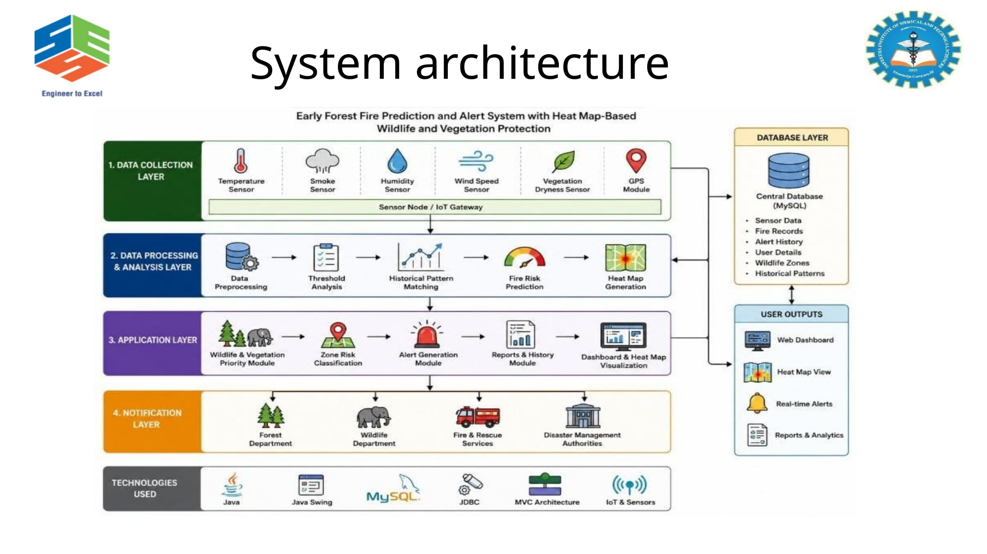
System-level interaction: Module 1 authenticates users and supplies environmental observations. Module 2 analyses current sensor conditions and historical patterns to classify fire risk. Module 3 combines predicted risk with wildlife density and vegetation coverage to generate response priorities. Module 4 communicates High/Critical conditions to authorized officials with GPS and environmental details and stores alert history.

3.6 Trade-off Analysis
Design Decision | Alternative Considered | Benefit | Disadvantage | Final Decision & Justification
Threshold + historical-pattern prediction | Threshold-only detection | Reduces dependence on a single condition and can reduce false alarms | Requires historical data | Selected because the PPT explicitly combines thresholds and historical patterns.
Priority-based heat map | Risk map without ecological weighting | Protects high-risk, ecologically sensitive zones first | Requires wildlife/vegetation information | Selected because wildlife density and vegetation coverage are core to the objective.
Authorized alerts | Alerts to all users | Improves security and relevance | Requires user authorization | Selected because the PPT specifies authorized forest officials.

3.7 Sustainability, Ethics, Safety, Risk & Security
Domain | Consideration | Evidence Evaluated | Impact on Final Decision
Sustainability | Protection of forests, wildlife, vegetation and biodiversity | Project purpose and explicit SDG 15 linkage | Environmental protection is a primary design objective.
Ethics | Limit alerts/access to authorized personnel | Authorized-user requirement in Modules 1 and 4 | Access control is included in the architecture.
Health & Safety | Rapid communication of High/Critical risk | Alert module and emergency-response purpose | GPS-based alerts support rapid action.
Security | Authentication and restricted notification recipients | Secure login and authorized-personnel notifications | Security is built into monitoring and alerting.

Risk Register
Risk | Likelihood | Severity | Risk Level | Mitigation | Residual Risk
Sensor failure / poor sensor quality | Medium | High | High | Sensor validation, maintenance and cross-checking where available | Medium
Harsh weather affects sensing | Medium | Medium | Medium | Monitor sensor health and interpret readings with environmental context | Low–Medium
Network connectivity failure | Medium | High | High | Store local records where possible and retry/restore communication | Medium
False positive prediction | Medium | Medium | Medium | Use thresholds plus historical-pattern analysis | Low–Medium
Unauthorized access | Low–Medium | High | High | Secure login and authorized-user controls | Low–Medium
Incorrect GPS/location data | Low–Medium | High | High | Validate location data before alert generation | Medium

CHAPTER 4
IMPLEMENTATION, TESTING & RESULTS, PROJECT MANAGEMENT

4.1 Development Approach & Resources
The system is structured using object-oriented analysis and design concepts and is divided into four functional modules. The design begins with secure forest monitoring, passes collected data to prediction, converts risk into ecological priority, and then triggers authorized emergency notifications. The project references Java and MySQL documentation, but the submitted PPT does not show implementation code, database schema, hardware specifications, or measured deployment results; these details are therefore not claimed beyond the evidence available.

4.2 Hardware / Software / Fabrication Implementation & Modern Tools Used
Tool / Software / Equipment | Purpose | Stage Used
Environmental sensors | Capture temperature, smoke, humidity and environmental conditions | Monitoring input; specific models not specified
GPS | Provide location for monitoring and alerts | Monitoring / alerting
Java Platform SE | Referenced software-development platform | Implementation reference; exact usage not shown
MySQL 8.0 | Referenced relational database platform | Data-management reference; exact schema not shown
UML | System modelling | Analysis and design
SMS / application notifications | Communicate High/Critical alerts | Emergency notification design

IMPLEMENTATION
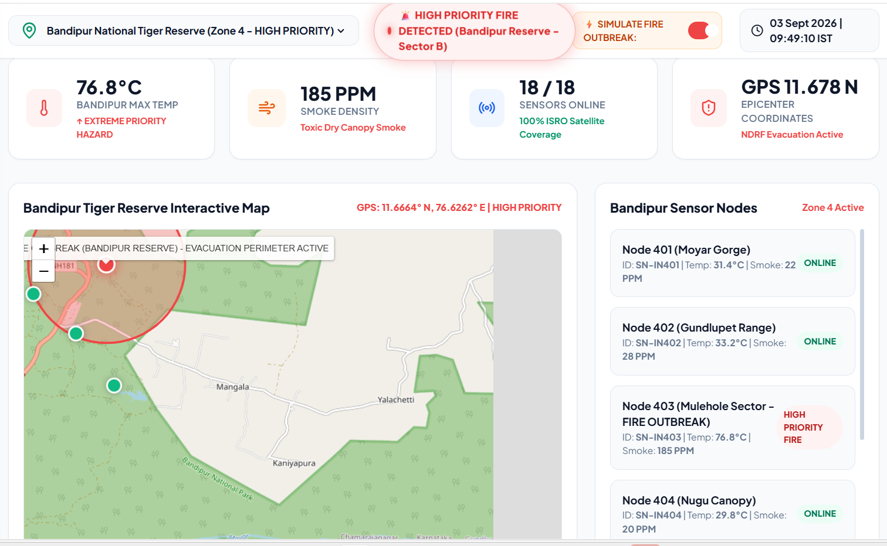
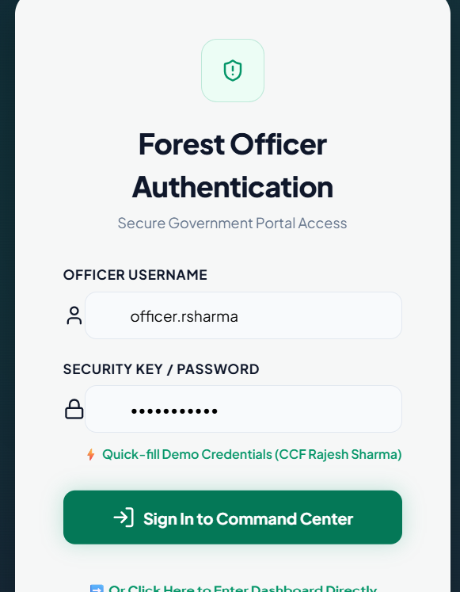

4.3 Test Plan & Verification
The PPT does not provide measured test results. The following is therefore a verification plan derived directly from the stated functions and objectives.
Requirement | Test Method | Acceptance Criterion
User authentication | Attempt authorized and unauthorized login | Only authorized users obtain access.
Environmental monitoring | Feed normal and abnormal environmental readings | Readings are collected and transferred to prediction.
Risk classification | Test readings below/near/above thresholds with historical context | System produces Low/Medium/High/Critical classification.
Heat-map priority | Provide combinations of risk, wildlife density and vegetation coverage | Priority 1–4 is assigned according to defined rules.
High/Critical alert | Trigger High and Critical risk cases | Alert is sent only to authorized officials and includes required details.
Alert history | Generate multiple alerts and inspect records | Alert history contains the generated events.

Verification status summary
Specification | Required Value | Achieved Value | Status
Four modules defined | 4 | 4 modules described in PPT | Pass
Risk levels | Low/Medium/High/Critical | Explicitly defined in PPT | Pass
Heat-map priorities | Priority 1–4 | Explicitly defined in PPT | Pass
GPS alert contents | Location + environmental/risk details | Explicitly specified in PPT | Pass
Quantitative performance | Measured results | Not reported in PPT | Not assessed
Field/deployment validation | Evidence required | Not reported in PPT | Not assessed

4.4 Results
The project presentation reports qualitative outcomes rather than numerical measurements. It states that the proposed system predicts forest fires at an early stage, provides real-time monitoring, generates a priority-based heat map, and sends instant GPS-based alerts to authorized officials. The conclusion states that these functions are intended to reduce forest-fire damage, improve emergency response, and protect wildlife and vegetation more effectively. No quantitative accuracy, response-time, false-alarm, sensor-performance, or field-deployment results are provided in the PPT.

4.5 Data Analysis & Engineering Judgment
Since no experimental dataset or measured performance results are supplied, quantitative statistical analysis cannot be supported from the source material. Engineering judgment is instead based on the stated design logic: combining threshold values with historical patterns is intended to reduce false alarms; ecological weighting is used to prioritize areas where wildlife and vegetation are dense; and GPS-based notifications provide actionable location information. The major dependencies are sensor quality, data availability, harsh weather conditions and network connectivity, which are explicitly listed as limitations in the PPT.

4.6 Comparison with Existing Solutions & Achievement of Objectives
Objective | Evidence | Achievement (Fully / Partially / Not Achieved)
Early prediction using real-time environmental data | Monitoring collects temperature, smoke, humidity, weather and GPS; prediction classifies risk. | Partially evidenced — no quantitative validation reported.
Priority-based heat map | Module 3 assigns Priority 1–4 using risk, wildlife density and vegetation coverage. | Partially evidenced — no field validation reported.
Instant GPS alerts to officials | Module 4 specifies alerts for High/Critical risk with GPS and risk details. | Partially evidenced — no delivery-time measurements reported.

4.7 Strengths & Limitations
Strengths:
- Early-risk prediction rather than relying only on post-ignition detection.
- Real-time environmental monitoring.
- Priority-based heat map that incorporates ecological sensitivity.
- Instant alerts containing GPS and fire-risk information.
- Security through authenticated access and authorized recipients.
Limitations:
- Prediction accuracy depends on sensor quality and data availability.
- Harsh weather or sensor failures may affect performance.
- Reliable network connectivity is required for real-time alerts.
- Initial installation and maintenance costs can be high.
- Quantitative field-test results are not provided in the PPT.

4.8 Project Planning, Roles & Budget
Milestone | Planned Activity
1 | Problem identification and environmental-risk requirements
2 | Literature / technical reference review
3 | Four-module system and UML design
4 | Monitoring, prediction, heat-map and alert implementation
5 | Testing and verification
6 | Analysis, documentation and presentation

Student | Assigned Responsibility | Actual Contribution
Chethrika Sri | Module 1 and Module 3 | User Authentication & Forest Monitoring; Priority-Based Heat Map Generation; related design, verification and report sections.
Kamali R | Module 2 | Forest Fire Prediction; related design, verification and report sections.

Item | Estimated Cost | Actual Cost
Sensors / GPS hardware | 0 | 0
Software / database resources | 0 | 0
Network / notification services | 0 | 0

CHAPTER 5
CONCLUSION, FUTURE WORK AND REFLECTION

5.1 Conclusion
The proposed Early Forest Fire Prediction and Alert System with Heat Map-Based Wildlife and Vegetation Protection combines real-time environmental monitoring, early fire-risk prediction, ecological priority mapping and immediate alerting. The design addresses the project problem by linking sensor observations to Low/Medium/High/Critical risk levels, then using wildlife density and vegetation coverage to prioritize response zones. High and Critical conditions are communicated to authorized forest officials with GPS and relevant environmental information. The project supports protection of forests, wildlife and vegetation and explicitly aligns its environmental purpose with SDG 15 – Life on Land. The source presentation does not provide numerical validation, so further field testing is required before claims of measured prediction accuracy or response performance can be made.

5.2 Future Work
- Integrate satellite and drone data for improved detection and situational awareness.
- Use advanced AI models for fire-spread prediction.
- Develop a mobile application for real-time monitoring.
- Integrate automatic emergency response and resource allocation.
- Expand the system to monitor larger forest regions.

5.3 Professional Learning & Individual Reflection
New Knowledge Acquired:
- Understanding of environmental monitoring requirements for forest-fire prediction.
- Understanding of risk classification and priority-based ecological decision-making.
- Awareness of GPS-based emergency communication and authorized-access requirements.
- Application of UML and modular object-oriented design to an environmental protection system.
Engineering & Professional Skills Developed:
- Requirements analysis and modular system decomposition.
- Risk and trade-off analysis.
- System-level thinking across monitoring, prediction, mapping and alerting.
- Technical documentation, teamwork and engineering communication.

Individual Reflection –
Chethrika Sri (192511112)
Module 1 – User Authentication & Forest Monitoring
As part of Module 1, I worked on the User Authentication and Forest Monitoring component of the Early Forest Fire Prediction and Alert System. This module helped me understand the importance of secure access and reliable environmental data collection in a real-time monitoring system. I learned how parameters such as temperature, smoke, humidity, weather conditions and GPS location can be continuously monitored and transferred to the fire prediction module. Working on this module improved my understanding of how input data acts as the foundation for the subsequent prediction and alert-generation processes. I also gained knowledge about the importance of authorized access, data reliability and continuous monitoring in an environmental safety application. This work strengthened my understanding of object-oriented analysis and system-level thinking.
Module 3 – Priority-Based Heat Map Generation
In Module 3, I worked on the Priority-Based Heat Map Generation component. Through this module, I learned how predicted fire risk can be combined with wildlife density and vegetation coverage to identify areas that require different levels of protection. I understood the concept of classifying forest regions into Priority 1, Priority 2, Priority 3 and Priority 4, where areas with high fire risk and highly dense wildlife or vegetation receive the highest priority. This module helped me understand how system outputs can be converted into meaningful visual information to support faster decision-making and resource allocation. I also gained a better understanding of how OOAD concepts can be applied to a real-world environmental protection problem.
Overall Reflection
Working on Modules 1 and 3 gave me practical exposure to analyzing a real-world problem and dividing it into functional system components. I improved my understanding of requirements analysis, system design, environmental data processing, prioritization and UML-based object-oriented design. The project also made me realize the importance of data accuracy, system reliability, security and sustainability when designing technology for critical applications. Overall, this project improved my technical knowledge as well as my ability to analyze problems, design solutions and contribute effectively to a team-based engineering project.
.

REFERENCES
[1] G. Booch, J. Rumbaugh, and I. Jacobson, The Unified Modeling Language User Guide, 2nd ed. Addison-Wesley Professional, 2005.
[2] R. S. Pressman and B. R. Maxim, Software Engineering: A Practitioner's Approach, 9th ed. McGraw-Hill Education, 2019.
[3] Oracle Corporation, Java Platform, Standard Edition Documentation, 2025.
[4] Oracle Corporation, MySQL 8.0 Reference Manual, 2025.
[5] United Nations, Sustainable Development Goal 15: Life on Land, 2025.
Note: These references are taken from the submitted PPT. URLs, DOIs and additional publication metadata were not provided in the source.

APPENDICES
APPENDIX A – DETAILED DESIGN CALCULATIONS / DECISION LOGIC
This appendix documents the decision logic represented in the project presentation. Numerical sensor thresholds are intentionally not assigned because the provided project material does not specify calibrated threshold values.

A.1 Risk Classification Logic
Risk Level | Decision Interpretation | System Response
Low | Environmental readings do not indicate a significant fire condition. | Continue monitoring.
Medium | Moderate abnormal environmental conditions are observed. | Increase attention and continue analysis.
High | Strong abnormal conditions indicate a possible fire event. | Generate an alert and prioritize the affected area.
Critical | Severe conditions indicate an urgent fire threat. | Generate an urgent alert and prioritize immediate response.

A.2 Priority-Based Protection Logic
Priority | Risk / Ecological Condition | Purpose
Priority 1 | High fire risk + highly dense wildlife/vegetation | Highest protection priority.
Priority 2 | High fire risk + moderate wildlife/vegetation | High protection priority.
Priority 3 | Medium fire risk + low wildlife/vegetation | Moderate protection priority.
Priority 4 | Low/no fire risk | Safe zone / lowest immediate priority.

A.3 Decision Flow
- Authenticate the user before access to monitoring information.
- Collect temperature, smoke, humidity, weather and GPS information.
- Compare current sensor values with predefined thresholds.
- Use historical fire patterns together with current environmental conditions.
- Classify the predicted condition as Low, Medium, High or Critical.
- Combine predicted risk with wildlife density and vegetation coverage.
- Assign Priority 1–4 and update the heat-map representation.
- For High or Critical risk, generate an alert containing GPS location, temperature, smoke, risk, priority and affected area.
- Store alert history for authorized users.

A.4 Reference Pseudocode
START
Authenticate authorized user
Collect environmental data and GPS
IF data is available THEN
Compare readings with predefined thresholds
Analyze historical fire patterns
Determine risk level: Low / Medium / High / Critical
Determine ecological priority: 1 / 2 / 3 / 4
Update heat map
IF risk is High OR Critical THEN
Generate alert with location and environmental details
Record alert in history
END IF
ELSE
Report unavailable/incomplete sensor data
END IF
END

APPENDIX B – ENGINEERING DRAWINGS
The system architecture and UML representation included in the project presentation form the principal engineering drawings for this report. They describe interaction among authentication, forest monitoring, prediction, priority heat-map generation and alert notification components.
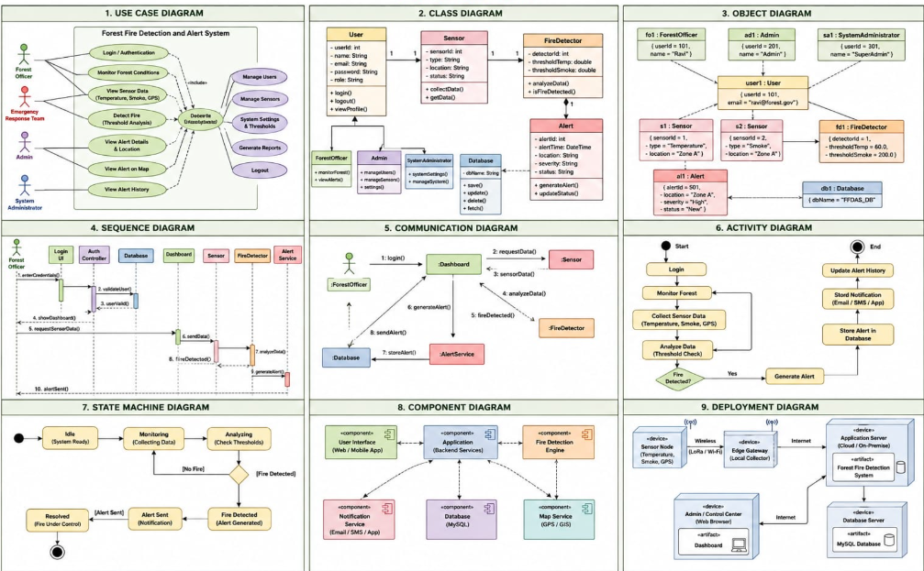

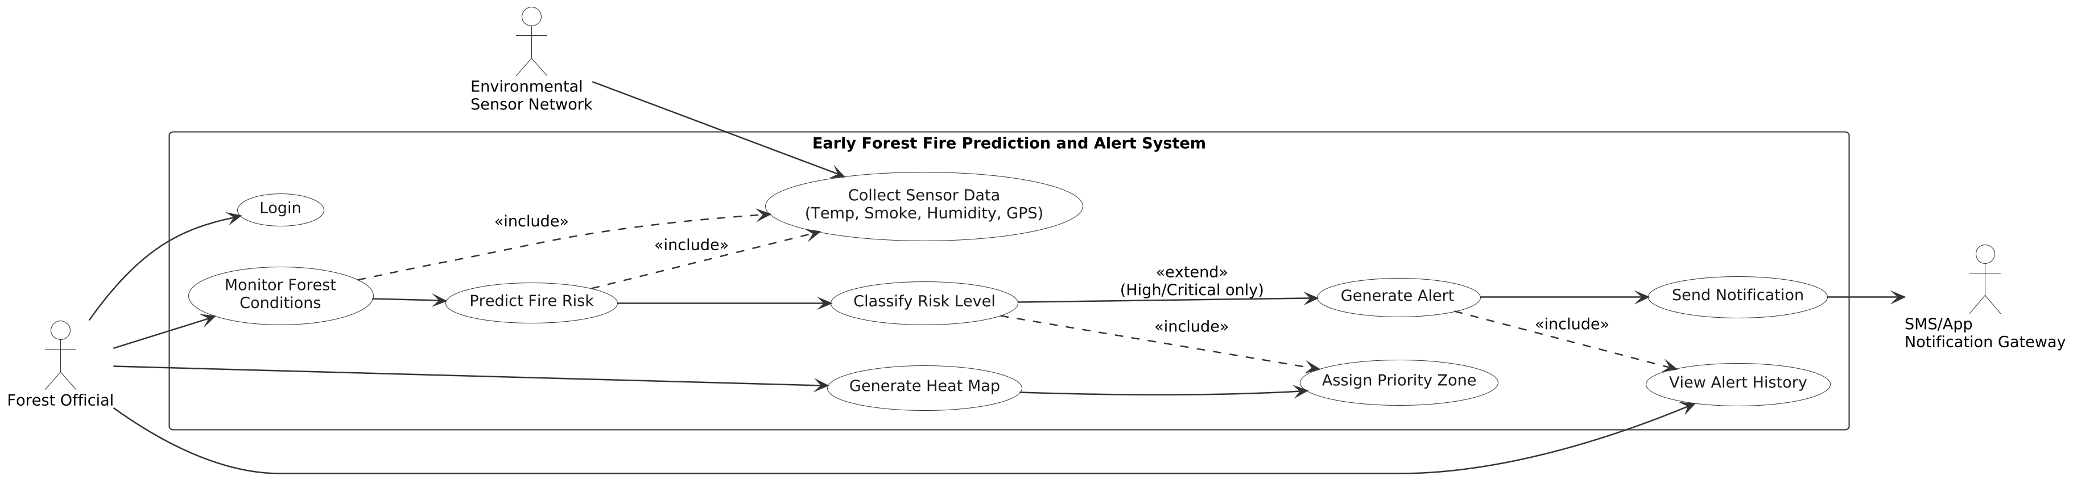

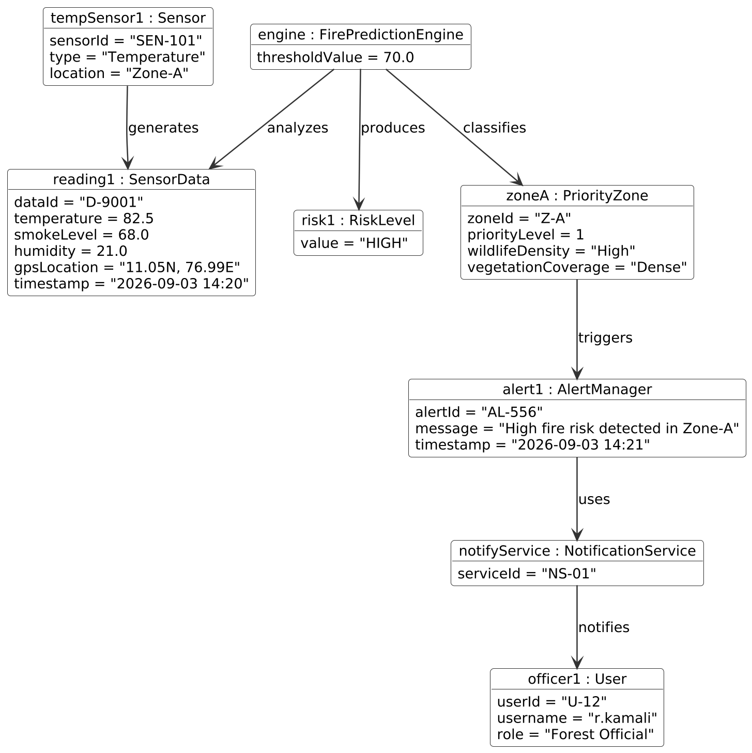
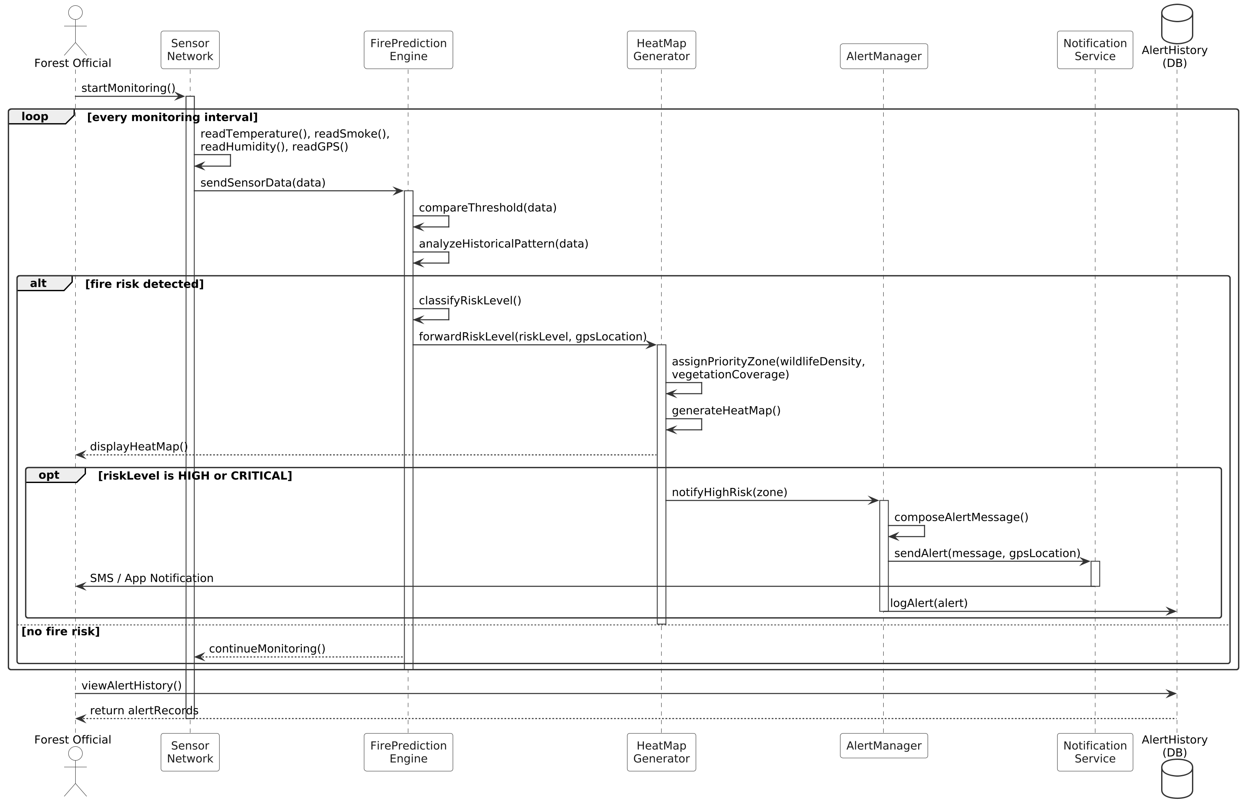
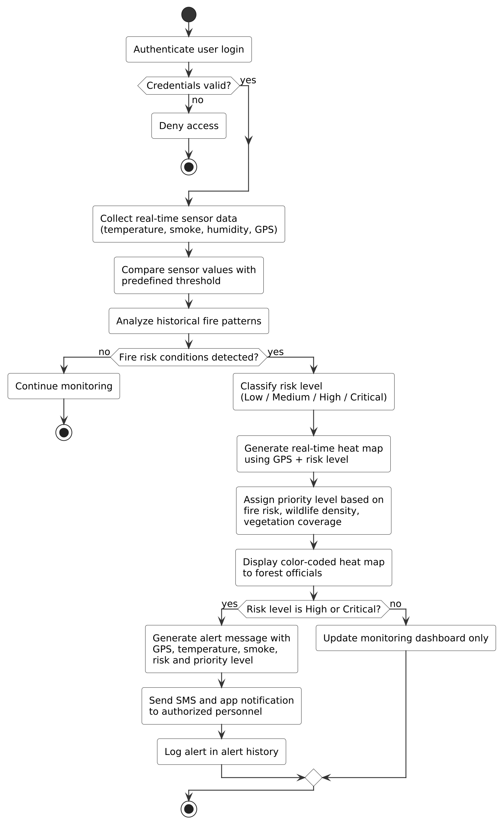
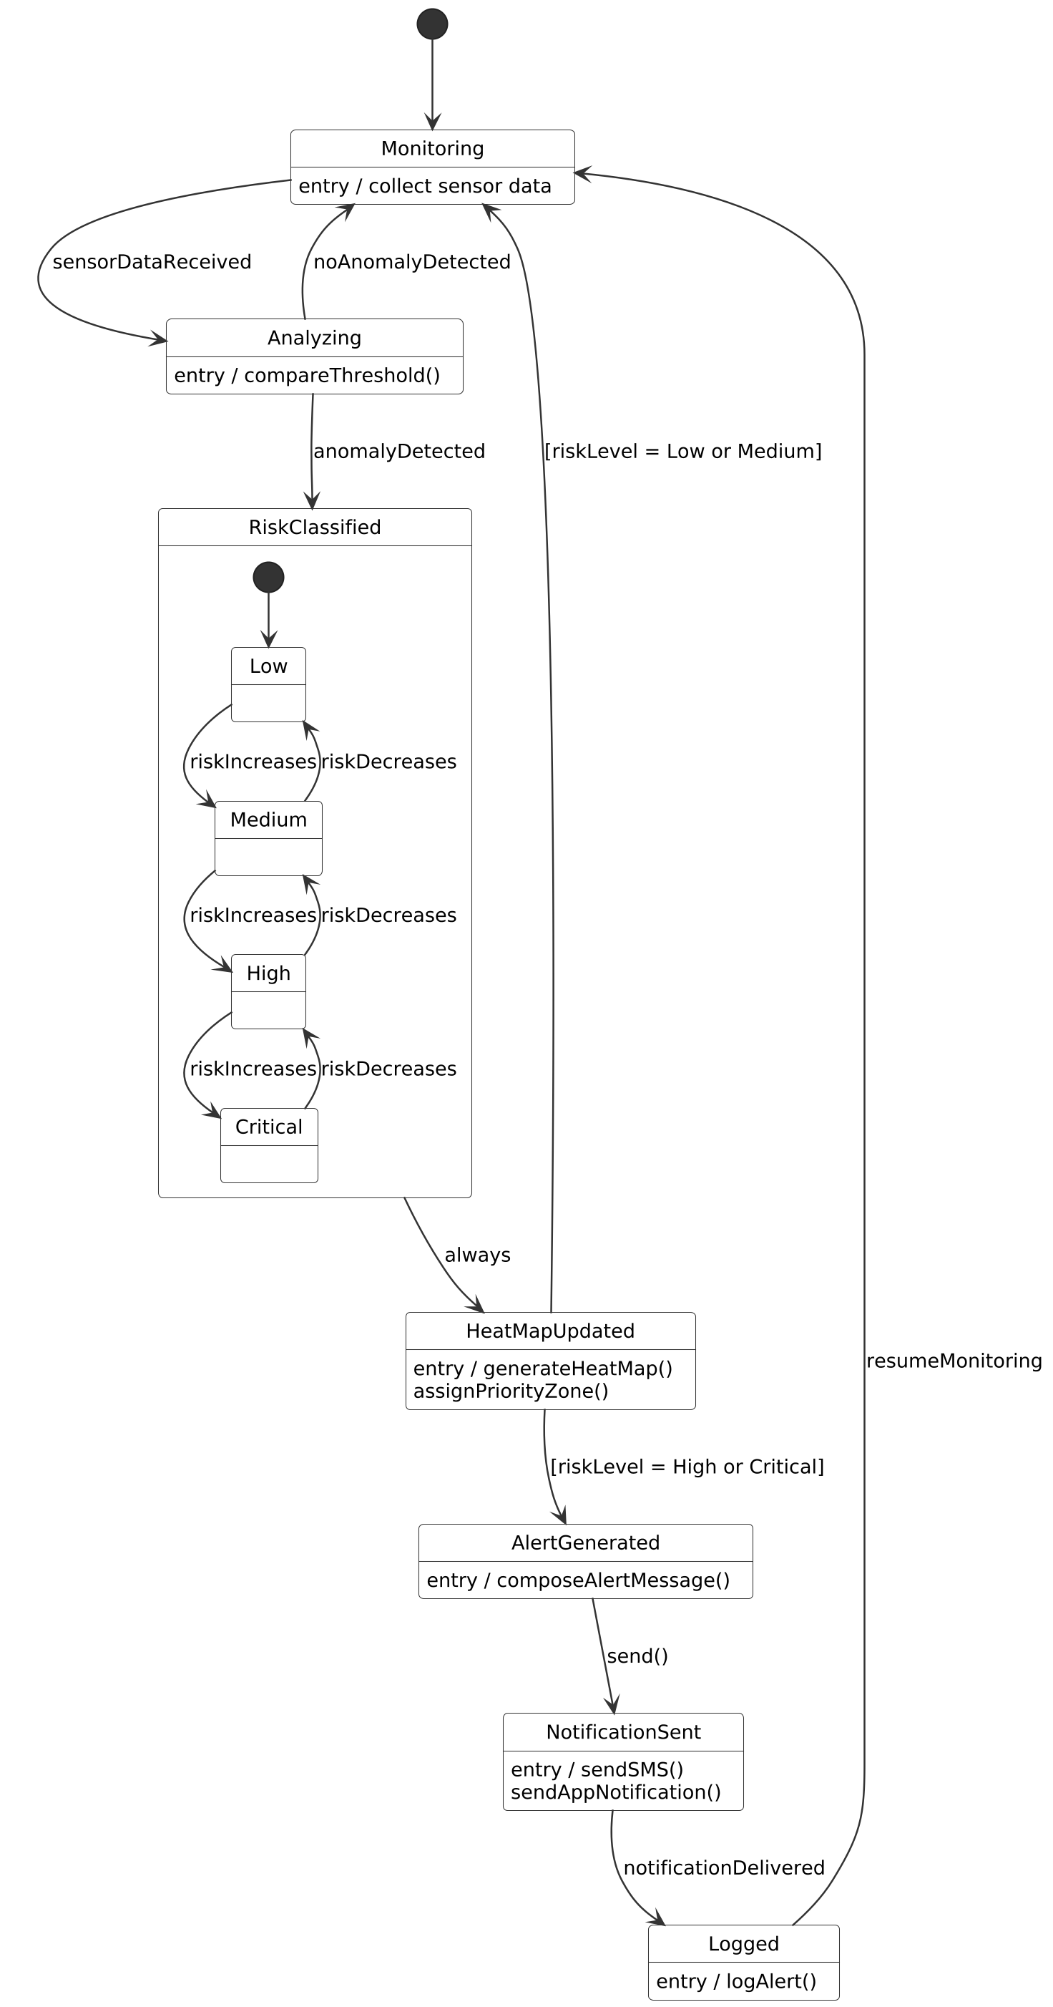
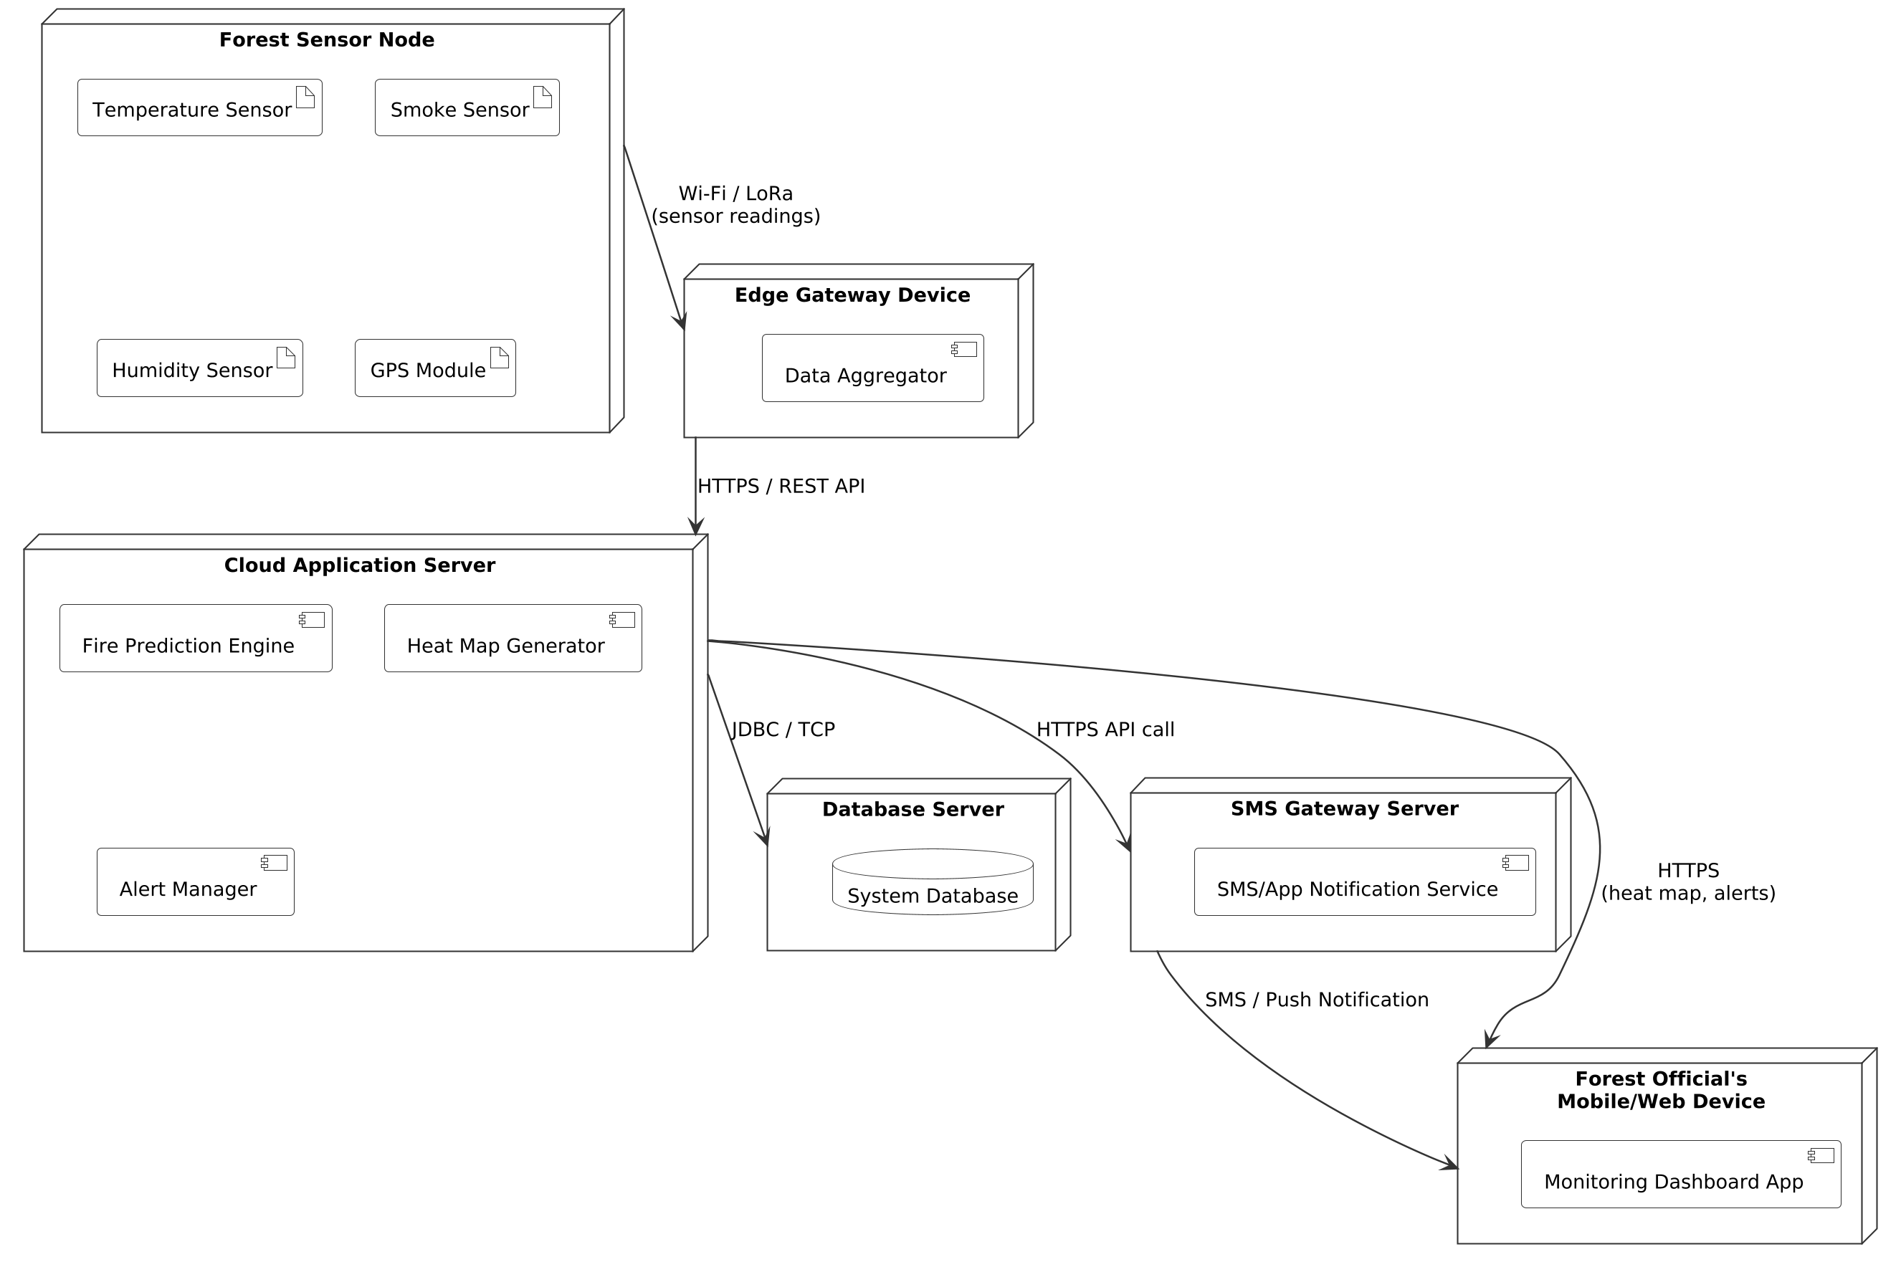
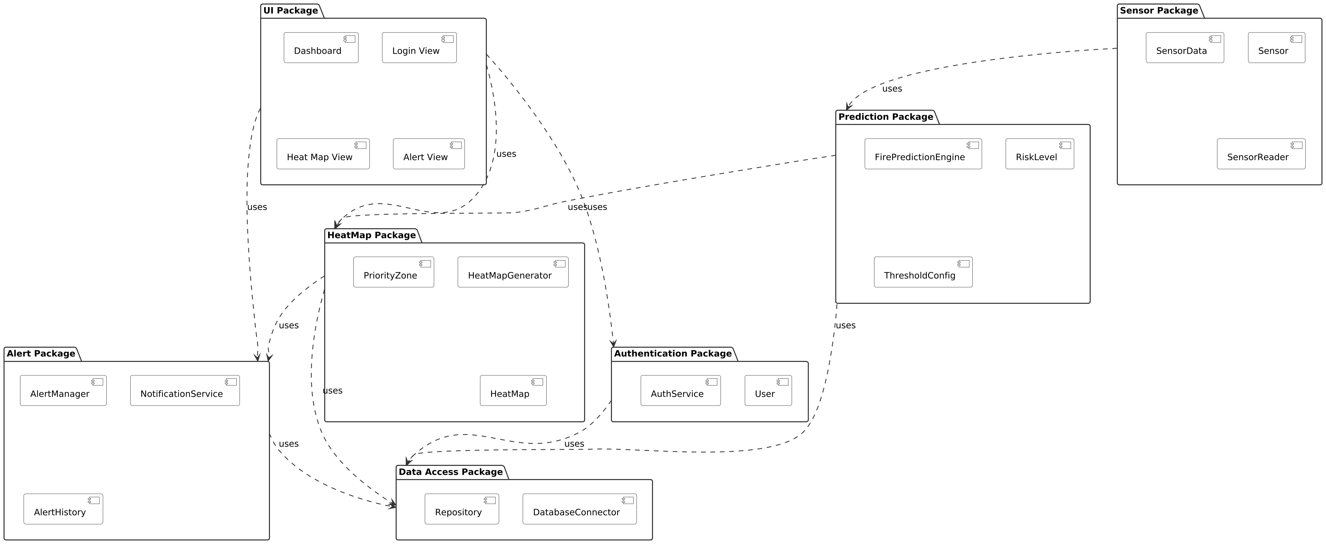

APPENDIX C – SOURCE CODE / REFERENCE PSEUDOCODE
The project presentation does not provide a complete source-code listing. The following reference pseudocode expresses the proposed functional behavior and is included as design documentation, not as a claim of a completed implementation.

C.1 Forest Fire Prediction
FUNCTION predictFireRisk(environmentData, historicalPatterns)
thresholdResult = compareWithThresholds(environmentData)
patternResult = analyzeHistoricalPatterns(historicalPatterns, environmentData)
IF thresholdResult indicates severe abnormality AND patternResult indicates fire possibility
RETURN "Critical"
ELSE IF thresholdResult indicates high abnormality
RETURN "High"
ELSE IF thresholdResult indicates moderate abnormality
RETURN "Medium"
ELSE
RETURN "Low"
END IF
END FUNCTION

C.2 Priority Assignment
FUNCTION assignPriority(riskLevel, wildlifeDensity, vegetationCoverage)
IF riskLevel == "High" AND wildlifeDensity == "High" AND vegetationCoverage == "High"
RETURN Priority 1
ELSE IF riskLevel == "High" AND ecological density is Moderate
RETURN Priority 2
ELSE IF riskLevel == "Medium" AND ecological density is Low
RETURN Priority 3
ELSE
RETURN Priority 4
END IF
END FUNCTION

C.3 Alert Generation
IF riskLevel == "High" OR riskLevel == "Critical"
Create alert
Attach GPS location
Attach temperature and smoke information
Attach risk level and priority
Attach affected-area information
Send notification to authorized personnel
Store alert in history
END IF

PROJECT REPOSITORY
GitHub Repository: https://github.com/chethrikasri9-bot/CSA1109-OOAD
GitHub Profile: https://github.com/chethrikasri9-bot
The CSA1109-OOAD repository is publicly accessible and contains the project materials and commit history. citeturn0view0

APPENDIX D – SENSOR AND INTERFACE DATASHEET TEMPLATE
Specific sensor manufacturer, model numbers and calibrated specifications were not supplied in the project presentation. The following template records the engineering information to be completed when the physical implementation is finalized.
Parameter | Purpose | Expected Information | Actual Project Specification
Temperature | Detect abnormal heat conditions | Sensor model, range, accuracy, unit, sampling interval | Not specified in PPT
Smoke | Detect smoke-related fire indicators | Sensor model, detection principle, sensitivity, unit | Not specified in PPT
Humidity | Support environmental risk analysis | Sensor model, range, accuracy, sampling interval | Not specified in PPT
Weather | Provide environmental context | Source/sensor, parameters, update interval | Not specified in PPT
GPS | Locate the affected forest area | Module/source, coordinate format, accuracy | Not specified in PPT
Network/Communication | Transmit monitoring and alert information | Technology, range/coverage, availability | Reliable network required; specific technology not specified
Actual sensor datasheets, calibration records and interface specifications should be attached here if they become available.

APPENDIX E – EXPERIMENTAL / RAW DATA AND VERIFICATION RECORD
The project presentation does not contain measured experimental datasets or numerical test results. To avoid presenting invented measurements as project evidence, this appendix provides a structured record for actual data.

E.1 Recommended Raw-Data Format
Timestamp | Temperature | Smoke | Humidity | Weather | GPS | Predicted Risk | Priority | Alert
Actual test record | Enter measured value | Enter measured value | Enter measured value | Enter value | Enter coordinates | Low/Medium/High/Critical | 1/2/3/4 | Yes/No
Actual test record | Enter measured value | Enter measured value | Enter measured value | Enter value | Enter coordinates | Low/Medium/High/Critical | 1/2/3/4 | Yes/No

E.2 Verification Test Cases
Test ID | Test Condition | Expected Result | Evidence Status
TC-01 | Authorized user enters valid credentials | Access granted to monitoring functions | Implementation evidence not provided in PPT
TC-02 | Environmental readings remain within normal range | Low risk / continued monitoring | Implementation evidence not provided in PPT
TC-03 | Environmental readings show moderate abnormality | Medium risk classification | Implementation evidence not provided in PPT
TC-04 | Environmental readings indicate high fire possibility | High risk + priority assignment + alert | Implementation evidence not provided in PPT
TC-05 | Environmental readings indicate critical fire possibility | Critical risk + priority assignment + urgent alert | Implementation evidence not provided in PPT
TC-06 | High/Critical event includes GPS and environmental details | Alert contains required location and condition data | Implementation evidence not provided in PPT
TC-07 | Alert is generated | Alert is retained in alert history | Implementation evidence not provided in PPT

APPENDIX F – ETHICS, SAFETY AND ENVIRONMENTAL PROTECTION

F.1 Ethical Considerations
- Use the system only for authorized forest-monitoring and emergency-response purposes.
- Protect access to environmental, location and alert information from unauthorized users.
- Clearly distinguish predicted risk from confirmed fire so operators are not misled.
- Maintain traceable alert history so important decisions can be reviewed.
- Use wildlife and vegetation information responsibly, protecting sensitive ecological locations.

F.2 Safety Considerations
- A sensor-based prediction system should support, not replace, trained forest and emergency personnel.
- False negatives may delay response; false positives may consume emergency resources. Thresholds and historical analysis should therefore be validated before operational deployment.
- Sensor failure, harsh weather and network outages must be considered during maintenance and emergency planning.
- Personnel should not enter hazardous areas solely because the system reports a location; normal emergency and forest-safety procedures remain necessary.

F.3 Environmental Considerations
- The main environmental objective is to reduce damage to vegetation, wildlife and biodiversity through earlier detection and prioritization.
- Hardware deployment should minimize physical disturbance to forest ecosystems.
- Future large-scale deployments should consider energy consumption, maintenance access and responsible disposal of electronic components.

APPENDIX G – PROJECT MEETING / PROGRESS RECORD TEMPLATE
Actual meeting minutes were not supplied in the project presentation. The following milestone record is therefore a formal template rather than fabricated meeting evidence.
Stage | Planned Activity | Expected Output | Record / Evidence
1 | Problem identification and scope definition | Problem statement, aim and objectives | To be completed from actual project records
2 | Requirement analysis | Functional and non-functional requirements | To be completed from actual project records
3 | OOAD design | UML and system architecture | Project presentation available
4 | Prediction and priority logic | Risk classification and heat-map logic | Project presentation available
5 | Alert and notification design | Alert workflow and history concept | Project presentation available
6 | Testing and validation | Test results and evidence | Measured evidence not provided in PPT
7 | Final documentation | Capstone report and presentation | Current report

APPENDIX H – USER / INDUSTRY FEEDBACK RECORD
No formal user or industry feedback record was supplied in the project presentation. This appendix should be updated if feedback is collected from a faculty reviewer, forest professional, technical mentor or other stakeholder.
Stakeholder | Date | Feedback / Observation | Action Taken | Status
Faculty / Project Guide | Enter date | Enter actual feedback | Enter response/action | Open/Closed
Technical Reviewer | Enter date | Enter actual feedback | Enter response/action | Open/Closed
Potential User / Domain Expert | Enter date | Enter actual feedback | Enter response/action | Open/Closed

APPENDIX I – PROJECT OUTCOMES AND IMPACT

I.1 Sustainable Development Goal Mapping
The project is aligned with United Nations Sustainable Development Goal 15 – Life on Land, as stated in the project presentation. The intended contribution is protection of terrestrial ecosystems, wildlife and vegetation through earlier fire detection and prioritized response.

I.2 Objective-to-Outcome Mapping
Project Objective | Expected Outcome | Evidence Available
Predict forest fires early using real-time environmental data. | Early risk indication using environmental monitoring and prediction logic. | Design described in PPT
Generate a priority-based heat map for wildlife and vegetation protection. | Identification of critical ecological areas for response prioritization. | Design described in PPT
Provide instant GPS alerts to authorized forest officials. | Rapid notification containing location and fire-condition information. | Design described in PPT

I.3 Intended Engineering / Product Outcomes
- Reduced delay between abnormal environmental conditions and awareness of a possible fire.
- Better prioritization of areas where fire risk and ecological value overlap.
- Improved information available to authorized personnel during response.
- A foundation for future integration with satellite, drone, AI-based fire-spread prediction and mobile technologies.

I.4 Current Evidence Status
The supplied presentation establishes the proposed system concept, modules, architecture, UML representation, advantages, limitations and future enhancements. It does not provide a full set of measured performance metrics, deployment records or validated field-test results. Such evidence should be added when available.

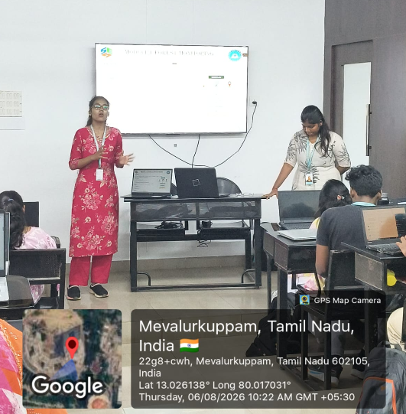
APPENDIX J – EVIDENCE

CAPSTONE PROJECT OUTCOME MAPPING SHEET

Outcome Area | Project Contribution | Status / Evidence
Engineering problem definition | Defines the forest-fire detection, prediction, ecological prioritization and alert problem. | Documented
OOAD analysis and design | Uses modular system design, UML and architecture to structure the solution. | Documented in PPT
Requirements and constraints | Considers sensor quality, weather, network availability and cost constraints. | Documented
Implementation / technical feasibility | Defines monitoring, prediction, heat-map and alert workflows. | Concept/design evidence
Testing and verification | Provides structured test cases for future implementation validation. | Test evidence not supplied
Sustainability and ethics | Targets protection of forests, wildlife, vegetation and biodiversity. | Documented
Safety and security | Includes authorized access, alert reliability and operational safety considerations. | Documented
Professional development | Demonstrates application of OOAD concepts to an environmental engineering problem. | Documented
Future innovation | Identifies satellite/drone data, AI fire-spread prediction, mobile app and automated response as enhancements. | Documented

PROJECT REPOSITORY
GitHub Repository: https://github.com/chethrikasri9-bot/CSA1109-OOAD
GitHub Profile: https://github.com/chethrikasri9-bot
The CSA1109-OOAD repository is publicly accessible and contains the project materials and commit history. citeturn0view0


